**CSCI 3170 Project Phase 1**

Liu Ho Man 1155077343

Wong Tsz Hin 1155079510

Kwok Tung Lim 1155079818

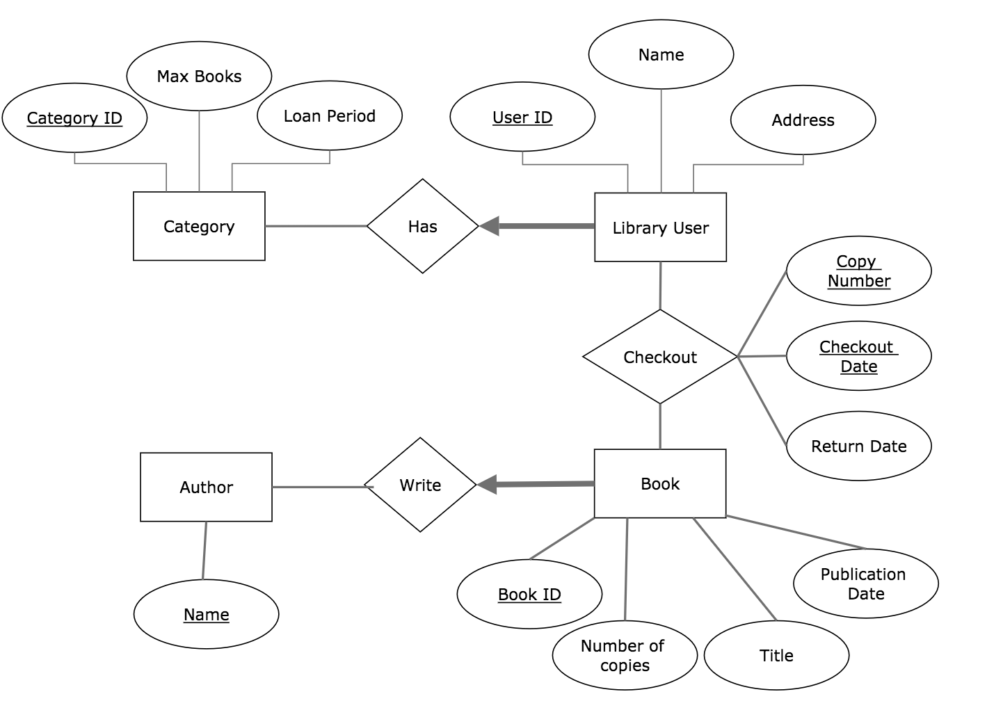ER Model

Relational Schema

- Category (Category ID, Max Books, Loan Period)

- Library User (User ID, Name, Address, Category ID)

- Checkout (User ID, Book ID, Copy Number, Checkout Date, Return Date)

- Book (Book ID, Number of copies, Title, Publication Date)

- Write (Book ID, Name)

- Author (Name)